Political Juggernauts:

A Quantitative Analysis of Candidates in the 2019

Lok Sabha Elections

1. **INTRODUCTION**
   1. Overview

General elections were held in India in seven phases from 11 April to 19 May 2019 to elect the members of the 17th Lok Sabha. Votes were counted and the result was declared on 23 May. The election resulted in a landslide victory for the BJP which won 303 seats and formed the government

.

* 1. Purpose

It is a massive exercise in the system of democratic governance. The Lok Sabha comprises of a total of 545 seats. Out of these, elections will be conducted by the Election Commission to fill 543 seats.

1. **Problem Definition & Design Thinking**
   1. Empathy Map

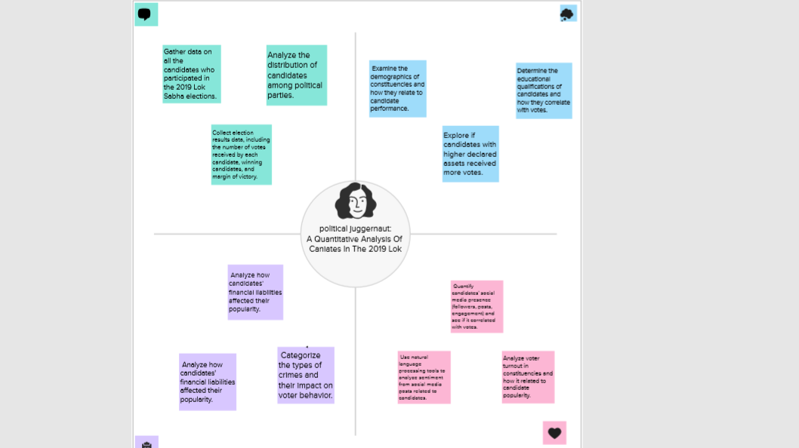

2.2 Ideation & Brainstorming Map

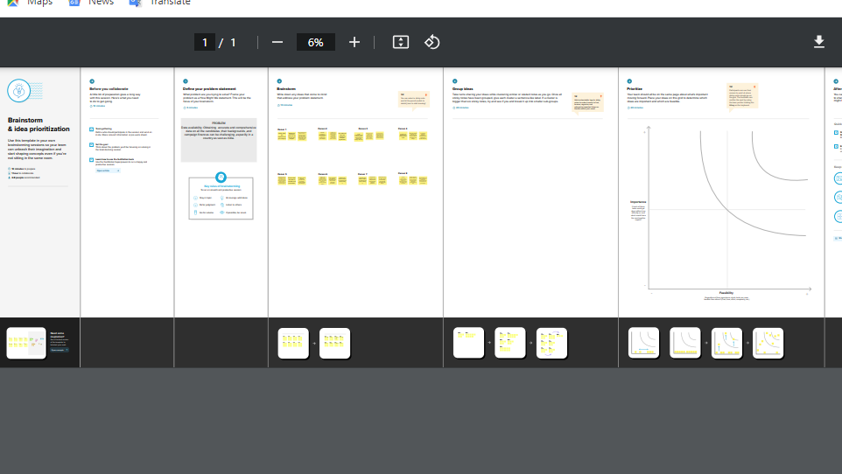

1. **RESULT**

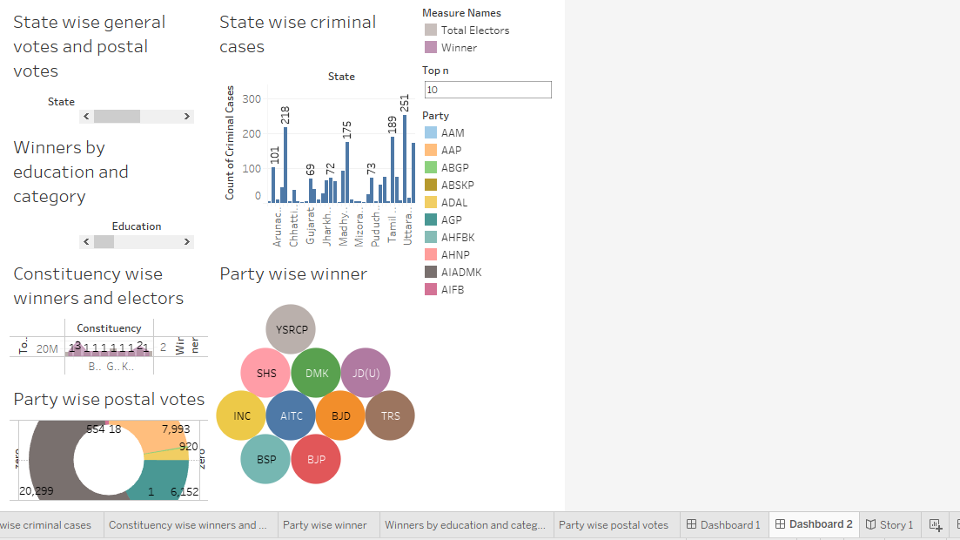

**Outgoing Ministers of State to lose in the election**

* [Manoj Sinha](https://en.wikipedia.org/wiki/Manoj_Sinha) - [Minister of State for Communications (Independent charge)](https://en.wikipedia.org/wiki/Ministry_of_Communications_(India)) ([Ghazipur](https://en.wikipedia.org/wiki/Ghazipur_(Lok_Sabha_constituency)" \o "Ghazipur (Lok Sabha constituency))) BJP
* [Alphons Kannanthanam](https://en.wikipedia.org/wiki/Alphons_Kannanthanam) - [Minister of State for Electronics and IT](https://en.wikipedia.org/wiki/Ministry_of_Electronics_and_Information_Technology) and [Minister of State for Tourism (Independent charge)](https://en.wikipedia.org/wiki/Ministry_of_Tourism_(India)) ([Ernakulam](https://en.wikipedia.org/wiki/Ernakulam_(Lok_Sabha_constituency)" \o "Ernakulam (Lok Sabha constituency))) BJP
* [Hardeep Singh Puri](https://en.wikipedia.org/wiki/Hardeep_Singh_Puri) - [Minister of State for Housing and Urban Poverty Alleviation](https://en.wikipedia.org/wiki/Ministry_of_Housing_and_Urban_Poverty_Alleviation) ([Amritsar](https://en.wikipedia.org/wiki/Amritsar_(Lok_Sabha_constituency))) BJP
* [Hansraj Gangaram Ahir](https://en.wikipedia.org/wiki/Hansraj_Gangaram_Ahir) - [Minister of State for Home Affairs](https://en.wikipedia.org/wiki/Ministry_of_Home_Affairs_(India)) ([Chandrapur](https://en.wikipedia.org/wiki/Chandrapur_(Lok_Sabha_constituency)" \o "Chandrapur (Lok Sabha constituency)))
* [Pon Radhakrishnan](https://en.wikipedia.org/wiki/Pon_Radhakrishnan) - [Minister of State for Finance](https://en.wikipedia.org/wiki/Ministry_of_Finance_(India)) ([Kanyakumari](https://en.wikipedia.org/wiki/Kanyakumari_(Lok_Sabha_constituency)" \o "Kanyakumari (Lok Sabha constituency))) BJP

**Former Prime Minister to lose in the election**

* [H. D. Deve Gowda](https://en.wikipedia.org/wiki/H._D._Deve_Gowda) ([JD-S](https://en.wikipedia.org/wiki/Janata_Dal_(Secular)))- [Prime Minister of India](https://en.wikipedia.org/wiki/Prime_Minister_of_India) from 1996–1997 lost from [Tumkur](https://en.wikipedia.org/wiki/Tumkur_(Lok_Sabha_constituency)" \o "Tumkur (Lok Sabha constituency)) of [Karnataka](https://en.wikipedia.org/wiki/Karnataka)[[178]](https://en.wikipedia.org/wiki/2019_Indian_general_election#cite_note-190)

**Former Chief Ministers to lose in the election**

* [H. D. Deve Gowda](https://en.wikipedia.org/wiki/H._D._Deve_Gowda) - [Karnataka](https://en.wikipedia.org/wiki/Karnataka) ([Tumkur](https://en.wikipedia.org/wiki/Tumkur_(Lok_Sabha_constituency)" \o "Tumkur (Lok Sabha constituency))) JD(S)
* [Sheila Dikshit](https://en.wikipedia.org/wiki/Sheila_Dikshit) - [Delhi](https://en.wikipedia.org/wiki/Delhi) ([North East Delhi](https://en.wikipedia.org/wiki/North_East_Delhi_(Lok_Sabha_constituency))) INC[[179]](https://en.wikipedia.org/wiki/2019_Indian_general_election#cite_note-191)
* [Digvijaya Singh](https://en.wikipedia.org/wiki/Digvijaya_Singh) - [Madhya Pradesh](https://en.wikipedia.org/wiki/Madhya_Pradesh) ([Bhopal](https://en.wikipedia.org/wiki/Bhopal_(Lok_Sabha_constituency))) INC
* [Sushil Kumar Shinde](https://en.wikipedia.org/wiki/Sushil_Kumar_Shinde) - [Maharashtra](https://en.wikipedia.org/wiki/Maharashtra) ([Solapur](https://en.wikipedia.org/wiki/Solapur_(Lok_Sabha_constituency)" \o "Solapur (Lok Sabha constituency))) INC[[180]](https://en.wikipedia.org/wiki/2019_Indian_general_election#cite_note-192)
* [Ashok Chavan](https://en.wikipedia.org/wiki/Ashok_Chavan) - [Maharashtra](https://en.wikipedia.org/wiki/Maharashtra) ([Nanded](https://en.wikipedia.org/wiki/Nanded_(Lok_Sabha_constituency)" \o "Nanded (Lok Sabha constituency))) INC[[181]](https://en.wikipedia.org/wiki/2019_Indian_general_election#cite_note-193)
* [Harish Rawat](https://en.wikipedia.org/wiki/Harish_Rawat) - [Uttarakhand](https://en.wikipedia.org/wiki/Uttarakhand" \o "Uttarakhand) ([Nainital–Udhamsingh Nagar](https://en.wikipedia.org/wiki/Nainital%E2%80%93Udhamsingh_Nagar_(Lok_Sabha_constituency)" \o "Nainital–Udhamsingh Nagar (Lok Sabha constituency))) INC
* [Bhupinder Singh Hooda](https://en.wikipedia.org/wiki/Bhupinder_Singh_Hooda) - [Haryana](https://en.wikipedia.org/wiki/Haryana) ([Sonipat](https://en.wikipedia.org/wiki/Sonipat_(Lok_Sabha_constituency)" \o "Sonipat (Lok Sabha constituency))) INC
* [Veerappa Moily](https://en.wikipedia.org/wiki/Veerappa_Moily) - [Karnataka](https://en.wikipedia.org/wiki/Karnataka) ([Chikkballapur](https://en.wikipedia.org/wiki/Chikkballapur_(Lok_Sabha_constituency)" \o "Chikkballapur (Lok Sabha constituency))) INC
* [Mukul Sangma](https://en.wikipedia.org/wiki/Mukul_Sangma) - [Meghalaya](https://en.wikipedia.org/wiki/Meghalaya) ([Tura](https://en.wikipedia.org/wiki/Tura_(Lok_Sabha_constituency))) INC
* [Nabam Tuki](https://en.wikipedia.org/wiki/Nabam_Tuki) - [Arunachal Pradesh](https://en.wikipedia.org/wiki/Arunachal_Pradesh) ([Arunachal West](https://en.wikipedia.org/wiki/Arunachal_West_(Lok_Sabha_constituency))) INC
* [Shibu Soren](https://en.wikipedia.org/wiki/Shibu_Soren) - [Jharkhand](https://en.wikipedia.org/wiki/Jharkhand) ([Dumka](https://en.wikipedia.org/wiki/Dumka_(Lok_Sabha_constituency)" \o "Dumka (Lok Sabha constituency))) JMM
* [Jitan Ram Manjhi](https://en.wikipedia.org/wiki/Jitan_Ram_Manjhi) - [Bihar](https://en.wikipedia.org/wiki/Bihar) ([Gaya](https://en.wikipedia.org/wiki/Gaya_(Lok_Sabha_constituency))) HAM
* [Babu Lal Marandi](https://en.wikipedia.org/wiki/Babu_Lal_Marandi) - [Jharkhand](https://en.wikipedia.org/wiki/Jharkhand) ([Kodarma](https://en.wikipedia.org/wiki/Kodarma_(Lok_Sabha_constituency)" \o "Kodarma (Lok Sabha constituency))) JVM(P)
* [Mehbooba Mufti](https://en.wikipedia.org/wiki/Mehbooba_Mufti) - [Jammu and Kashmir](https://en.wikipedia.org/wiki/Jammu_and_Kashmir_(state)) ([Anantnag](https://en.wikipedia.org/wiki/Anantnag_(Lok_Sabha_constituency)" \o "Anantnag (Lok Sabha constituency))) PDP

**4.ADVANTAGES & DISADVANTAGES**

## *n case 'One Nation One Election' is brought into force ahead of 2024 elections, Assemblies of at least 19 of 31 states and UTs will have to be dissolved.*

## Advantage of ‘One Nation One Election’

The biggest logic in the favor of the simultaneous election is the saving of government money. If the country goes for One Nation One Election it will saving of huge Government money. As per reports, a whopping Rs 60,000 crore was spent on the 2019 Lok Sabha elections. The amount includes what was spent by the political parties fighting the polls and the spending by the Election Commission of India (ECI) to hold the elections. The move might also lead to an increase in voter percentage and lesser corruption, besides saving time and energy.

## Disadvantage of ‘One Nation One Election’

It is observed that elections for state assemblies and LokSabha are fought on different issues. Regional parties target local issues while national parties target national issues. So there is a possibility that regional parties will not be able to raise the local issues strongly.

**5 APPLICATIONS**

The information on the status of MCC violation incidents is updated on the Election Commission of India (ECI) website at 6 pm every day displaying the status in the concerned division as on 12:00 pm of that day. Information received in the ECI section after 12 pm of the day shall be reflected in the status update of the next day

**6 CONCLUSION**

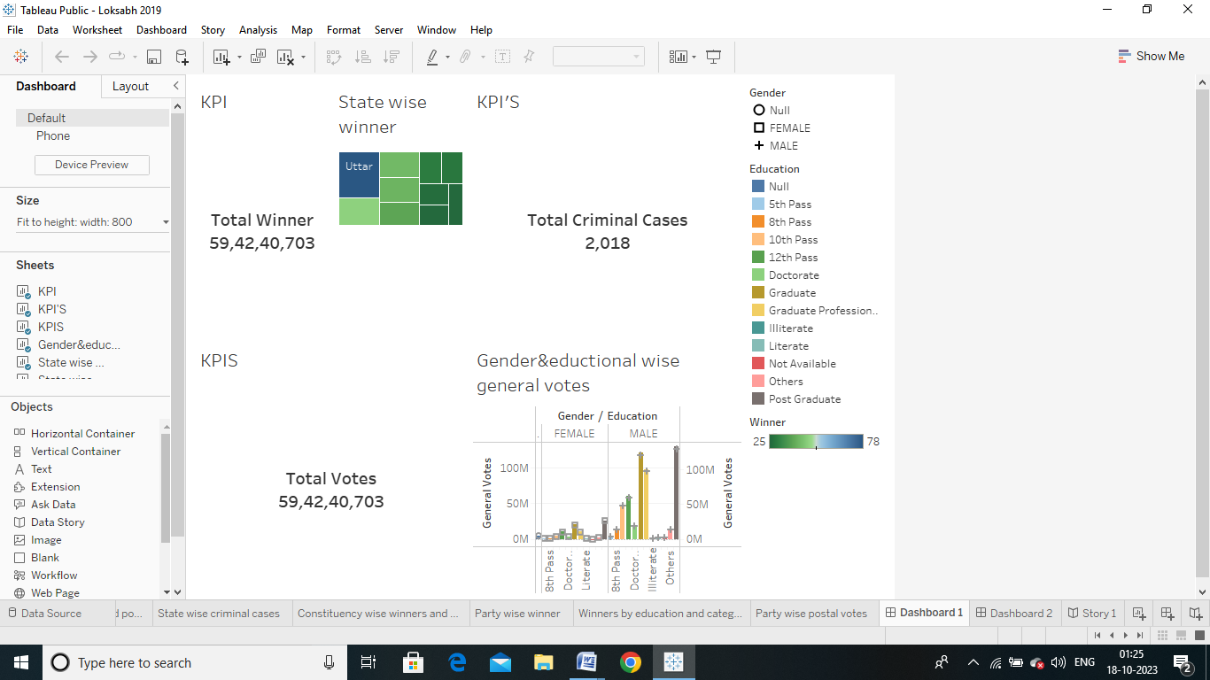

The [Bharatiya Janata Party](https://en.wikipedia.org/wiki/Bharatiya_Janata_Party" \o "Bharatiya Janata Party)-led [NDA](https://en.wikipedia.org/wiki/National_Democratic_Alliance_(India)) won the elections with the BJP itself winning a clear [majority](https://en.wikipedia.org/wiki/Majority). The BJP became the single largest party in the House and surpassed expectations to win 303 seats, with its alliance partners bringing the NDA to a total of 353 seats.[[3]](https://en.wikipedia.org/wiki/Results_of_the_2019_Indian_general_election#cite_note-4) Reasons attributed to the victory included the personal popularity of [Narendra Modi](https://en.wikipedia.org/wiki/Narendra_Modi" \o "Narendra Modi), effective voter turnout drives by the NDA, a surge in public nationalism following the [Pulwama attack](https://en.wikipedia.org/wiki/Pulwama_attack" \o "Pulwama attack), the consolidation of Hindu voters in a multi-caste coalition and the successful implementation of social welfare programmes during the [First Modi ministry](https://en.wikipedia.org/wiki/First_Modi_ministry)'s term.

**7. FUTURE SCOPE**

A research [paper](https://papers.ssrn.com/sol3/papers.cfm?abstract_id=4512936) by Ashoka University scholar Sabyasachi Das, titled ‘Democratic Backsliding in the World’s Largest Democracy’ seems to have stirred the hornet’s nest in certain political circles.

Das published this paper in the background of the credibility of the Election Commission of India (ECI) being called into question, with allegations of bias in scheduling of elections and arbitrary deletions of the names of registered Muslim voters. Both of these will have favoured the ruling Bharatiya Janata Party.

**8**

8. **APPENDIX**

Tableau ling; <https://public.tableau.com/app/profile/muthukrishnan.k/vizzes>

Nanmudhalvan ling;

K.Muthukrishnan;<https://naanmudhalvan-as.teachable.com/courses/enrolled/2160671>

N.Nagarasu; <https://naanmudhalvan-as.teachable.com/courses/enrolled/2160671>